Let’s Go Fly A Kite! Investigate the force of wind. – Science Experiment
Week of March 30 – April 3
You decide when to do this experiment this week. It will all depend on the weather!
Objective: using 3 different weighted objects: (1) feather (provided in envelope) and (2) other objects from your house -predict – investigate – record – movement of 3 chosen objects. Which objects moved longest or shortest distance?
- Order your 3 objects by their weight.
- Observe from an inside window any wind movement by looking at tree branches, leaves, bushes or other objects you notice outside your window. You will be doing this experiment two times – one time when you think there is little wind movement outside. The other time when you think there is a large amount of wind movement.
- Predict what will happen when you take the 3 objects outside when there is just a little amount of wind. Record your prediction below.
- Then predict what will happen to your objects with a stronger wind movement happens outside.
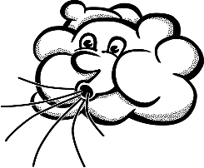
Record your
My Predictions

My Three Objects | - Will my object move in a small wind? | - Will my object move in a strong wind?
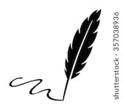  1.  feather | Yes no | Yes no
2. | Yes no | Yes no
3. | Yes no | Yes no

Questions to discuss together: Will your objects move the same the distance? Will some or all objects stay on the ground? Will some or all objects fly a little in the air?
- Go outside and investigate – what happened to your objects? Which object moved the longest distance? Which one move the shortest distance.
- On the back draw and write what you discovered in your 2 experiments (1 time when there was a small wind) (2nd time when there was a strong wind). Have fun investigating.
This is what my objects did when there was no wind or just a small amount.

__________________
This is what my objects did when there was a strong wind.
___________________

